Unit II
- Service Delivery Process:
- Service Level Management (SLM) deals with negotiating, agreeing and documenting existing services with some level of policies.
SLM deals with following two kinds of agreements −
- Service Level Agreement (SLA)
- Operational Level Agreement (OLA)

Service Level Agreement (SLA)
It is agreed document assuring the warranty with regard to level of service quality delivered by the service provider. It is between service provider and the customer.

Operational Level Agreement (OLA)

SLM Activities
The following diagram describes activities involved in SLM process −
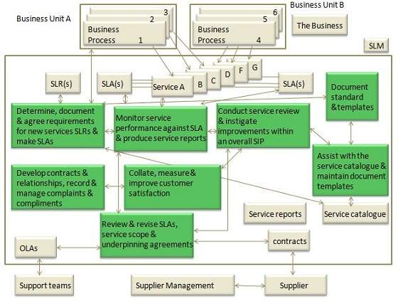

Objectives
Here are the objectives of SLM −
Define, document, agree, monitor, measure, report, and review the level of IT service provided.
Provide and improve the relationship and communication with the business and customers.
Ensure that specific and measurable targets are developed for all IT services.
Monitor and improve customer satisfaction with the quality of service delivered
Ensure that IT and customers have a clear and unambiguous expectation of the level of service to be delivered
- Financial Management
- Financial Management deals with accounting, budgeting and charging activities for services. It determines all the costs of IT organization on the basis of direct and indirect costs. This process is used by all three types of service providers – internal, external or shared service providers.

Benefits of Financial Management
Here are some of the benefits of Financial Management −
- Enhanced decision making
- Speed of change
- Service portfolio management
- Operational control
- Value capture and creation

Key decisions for Financial Management

Cost centre, value centre or accounting centre?
It is important to decide that how funding will be replenished. Clarity around the operating model greatly contributes to understanding the requisite, visibility of service provisioning costs, and funding is a good test of the business’s confidence and perception of IT.
The IT financial cycle starts with funding applied to the resources that create output which is identified as value by the customer. This value in turn includes the funding cycle to begin again.

Chargeback − to charge or not to charge
A chargeback model provides added accountability and visibility. Charging should add value to the business.
Chargeback models vary based on simplicity of calculations and the ability for the
business to understand them. Some sample chargeback model includes the following components –
Notional charges
This address whether a journal entry will be made to the corporate financial systems. Here we have two-book method in which one records costs in corporate financial systems while a second book is kept but not recorded.
This second book gives same information but reflects what would have happened if alternative method of recording had been used.
Tiered Subscription
It refers to varying levels of warranty and /or utility offered for a service, all of which have been priced, with appropriate chargeback model applied.
Metered usage
In this demand modeling is incorporated with utility computing capabilities to provide confidence in the capture of real-time usage.
Fixed or user cost
In this cost is divided by an agreed denominator such number of users.
Service Continuity Management
ITSCM ensures continuity of IT service in time of any disaster. It also evaluates the level of insurance we need to protect service assets and a manuscript to recover from a disaster.

Objective
The following diagram shows the several objectives of ITSCM −
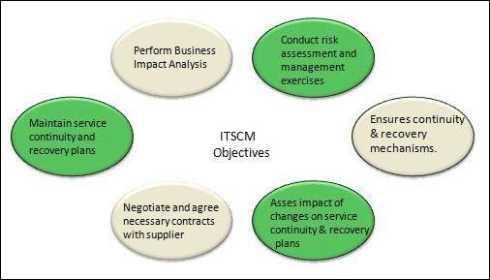

ITSCM Process
ITSCM process comprises of four stages − Initiation, Requirements & strategy, Implementation, and Ongoing operation.
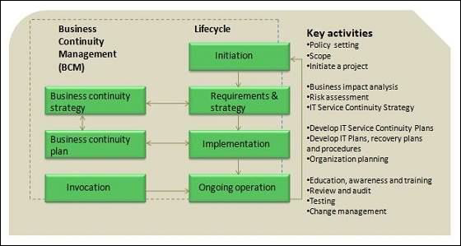

Initiation
It includes policy setting defining scope and terms of reference, project planning and resource allocation.

Requirements and strategy
It includes business impact analysis, risk assessment.

Implementation
It includes executing risk reduction measures, recovery option arrangements, testing and plans.
Capacity Management
Capacity Management ensures proper utilization of available resources and makes future capacity requirement available in cost-effective and timely manner. Capacity Management is considered during Service Strategy and Service Design phases.
It also ensures that IT is sized in optimum and cost-effective manner by producing and regularly upgrading capacity plan.

Capacity Management Activities
- The following table describes several activities involved in Capacity Management Process −
- Producing capacity plans, enabling service provider to continue to provide services of quality defined in SLA.
- Assistance with identification and resolution of any incident associated with any service or component performance.
- Understanding customer’s current and future demands for IT resources and producing forecasts for future requirements
- Monitoring Pattern of Business activity and service level plans through performance, utilization and throughput of IT services and the supporting infrastructure, environmental, data and applications components.
- Influencing demand management in conjunction with Financial Management
- Undertaking tuning activities to make the most efficient use of existing IT resources.
- Proactive improvement of service or component performance

Objectives
- Produce and maintain an appropriate up-to-date capacity plan reflecting the current and future needs of the business.
- Provide advice and guidance to all other areas of the business and IT on all capacity and performance related issues.
- To manage performance and capacity of both services and resources.
- Assisting with diagnosis and resolution of performance and capacity related incidents and problems.
- Assess the impact of all changes on the capacity plan, and the performance and capacity of services and resources.
- Ensure that proactive measures to improve the performance of services are implemented wherever it is cost justifiable to do so.

Capacity Management Elements
Capacity Management broadly includes three components: Business capacity management, Service capacity management, and Component capacity management as shown in the following diagram −
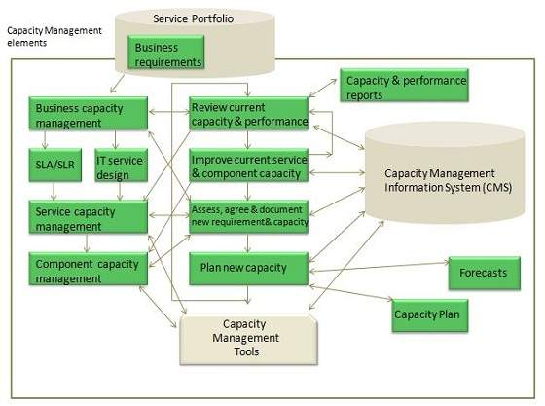

Business Capacity Management
This sub-process deals with forecasting and developing plans for future business needs. It is done by using existing data on current resource utilization by various services.

Service Capacity Management
This sub-process deals with understanding the functioning of IT service, resource usage and variation to ensure that appropriate service agreement can be designed.

Component Capacity Management
This sub-process ensures optimizing use of current IT resource components such as network capacity, bandwidth etc.

capacity Management Information System (CMIS)
CMIS maintains updated database of resources, commodities etc. which is used by all sub-processes within Capacity management.
Availability Management (AM)
ensures that IT services meet agreed availability goals. It also ensures new or changed service meet availability goals and doesn’t affect the existing services.

Objectives
Here are the objectives of Availability Management −
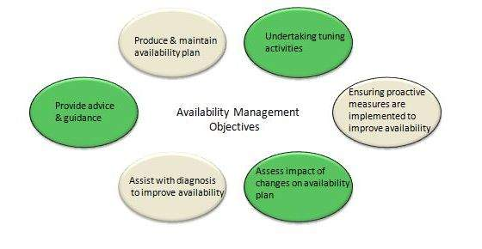

Availability Management Process
Availability Management process is comprises of following key elements −
- Reactive activities
- Proactive activities

Reactive activities
Activities that are involved in operational roles are known as reactive activities. Activities such as monitoring, measuring, analysis and management of all events, incidents and problem involving unavailability come under reactive activities.

Proactive activities
Activities that are involved in design and planning roles are known as proactive activities. Activities such as proactive planning, design & improvement of availability come under proactive activities.
Availability Management process is completed at following two interconnected levels −
- Service availability
- Component availability

Service availability
It deals with availability and unavailability of service and also the impact of component availability and unavailability on service availability.

Component availability
It deals with component availability and unavailability.
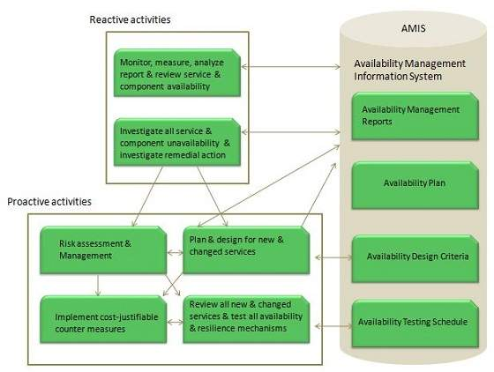

Availability Management sub-processes
The following diagram shows sub-processes involved in Availability Management process −

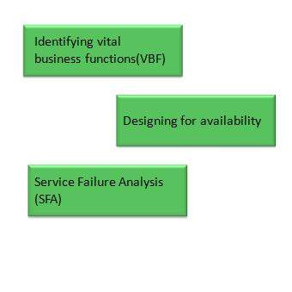Identifying vital business function (VBF)
VBF refers to business-critical elements that are supported by an IT service. It is important to document all VBFs to provide better business alignment and focus.

Designing for availability
Although additional costs are incurred in providing high availability solution to meet stringent high availability needs yet it is necessary to provide high availability of those services supporting to more critical VBFs.
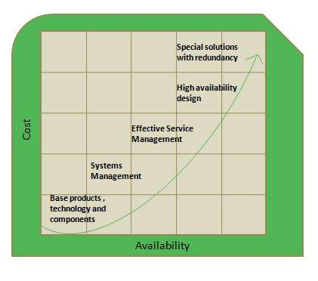

Service Failure Analysis (SFA)
Service Failure Analysis is designed to −
- Provide structured approach to identifying causes of service interruption to the user.
- Assess where and why shortfalls in availability are occurring.
- Improve overall availability of IT services by producing a set of improvement for implementation or input to Activity Plan.

